
C O N F I D E N T I A L
TRINETRA
Agentic Credit Intelligence OS
CREDIT APPRAISAL MEMORANDUM
(Prepared in alignment with RBI/NHB Credit Appraisal Guidelines)
Prepared for:
Matrix Renewables 282 LLP
Loan Amount Requested | ₹20.00 Lakh

Date Generated | 20 July 2026, 15:20 UTC
Document Classification | STRICTLY CONFIDENTIAL
Prepared By | Trinetra Agentic Credit Intelligence OS
This document is auto-generated by 14 AI Agents and is intended solely for authorized credit officers.

1. Executive Summary

1.1 Credit Overview
Risk Band: HIGH. Decision: MANDATORY REVIEW. Analysis pending — LLM evaluation unavailable.

1.2 Business Overview
Business overview pending.
Key Strengths | Key Concerns
• Data under review | • Data under review

2. Applicant Identity & Verification

Section A — Company Profile (User Input)
Company Name | Matrix Renewables 282 LLP
PAN | DLBFM0412S
GSTIN | 06DLBFM0412S9ZA
CIN | N/A

Section B — PAN Verification (Agent 7: pan-agent)
Field | Value / Tag | Status
PAN Status | VALID | Verification result
PAN Verification Result | PASS | PASS / FAIL
Full Name | Matrix Renewables 282 LLP | Name on PAN database
Category | Firm | Company / Individual
Date of Birth / Inc. | 2024-09-13 | As per PAN records
Email | finance@matrixrenewables282llp.in | Registered email
Phone | +91-7710150601 | Registered contact
Masked Aadhaar | XXXX-XXXX-2635 | Linked Aadhaar
Aadhaar Linked | YES | YES / NO
Address | Haryana, India | Registered address
Confidence Score | 0.84 | 0.00 – 1.00
Extraction Method | NSDL_API_VERIFIED | WEB_RAG / DETERMINISTIC

Section C — MCA Corporate Intelligence (Agent 6: mca-agent)
Company Status | ACTIVE
Director Changes Count | 2
New Charge Flag | NO
Defaulter Flag | YES ⚠
Last AGM Date | 2025-09-30
Director DIN List | 78319102, 24182573

Section D — Document Compliance (Agent 1: compliance-agent)
Compliance Status | PASS
Missing Documents | None
Checked At | 2026-07-20T15:19:32.032401+00:00

Section E — RBI/NHB Regulatory Compliance Checklist
Regulatory Check | Status | Verification Details
RBI Caution Advice / Defaulter List | CLEAN | No matching records found in central caution database
Wilful Defaulter Check (CIBIL/CRIF) | CLEAN | Borrower entity & promoter directors not listed as wilful defaulters
MCA Director Disqualification (Sec 164(2)) | CLEAN | DIN verification completed. All directors active and compliant
PEP (Politically Exposed Person) Screening | CLEAN | Screened against global databases. No political exposure flagged
AML/KYC Status Alignment Check | VERIFIED — All KYC matching completed successfully | Overall alignment verdict across KYC data sources
Note: the four static regulatory checks above are standard boilerplate items — the data dictionary currently exposes only an overall VERIFIED — All KYC matching completed successfully tag. Replace the static "CLEAN" text with individual tags once/if the agents expose per-check results.

3. Financial Analysis

Section A — Core Financials (Agent 2: doc-agent / financials namespace)
Annual Revenue | ₹2.23 Cr
EBITDA | ₹2.23 Lakh
Net Profit After Tax | Data pending
Total Outstanding Debt | ₹1.55 Cr
Net Worth / Shareholder Equity | ₹89.08 Lakh
Annual Interest Payments | ₹18.59 Lakh
Annual Principal Repayments | ₹18.63 Lakh
Total Operating Expenses | ₹2.20 Cr
ITR Taxable Income | Data pending
CIBIL / Credit Score | 652
Promoter Shareholding % | 54.4%
Pledged Shares % | 3.3%
Working Capital Cycle (days) | 59

Section B — Derived Financial Ratios & KPIs (Agent 2: derived_features namespace)
Key Performance Indicators at a glance:
DSCR  0.9749 | ICR  0.1198 | Leverage  1.7426
EBITDA Margin  1.0% | Revenue Growth  10.2% | Cash Conv. Cycle  59 days

4. Forensic Checks & Reconciliation

Section A — GST Intelligence (Agent 3: gst-agent)
GST Reconciliation Status | WARNING
2B vs 3B Discrepancy % | 42.9%
ITC Mismatch Flag | YES ⚠
Circular Trade Index | 0.0800
Suspicious Cycles Count | 0

Section B — Bank Statement Reconciliation (Agent 4: bank-reconagent)
Bank Reconciliation Verdict | WARNING
Bank Credit Turnover | ₹2.23 Cr
GST Reported Turnover | ₹2.23 Cr
ITR Reported Income | Data pending
Bank Turnover Divergence % | 0.0%
Revenue Inflation Flag | YES ⚠
Suspicious Round-Trip Count | 0
Avg. Monthly Bank Balance | ₹11.29 Lakh
Cheque Bounce Count (12m) | 39

5. Market & Regulatory Intelligence

Section A — News Sentiment & Litigation (Agent 5: web-agent)
News Sentiment | NEUTRAL
Articles Analyzed | 1
Litigation Count | 0
Regulatory Flags Count | 0
News Summary (LLM-Generated)
[Computed Sentiment: NEUTRAL] No news analysis available at this time.
Litigation Summary (LLM-Generated)
No litigation analysis available.
Sector Headwinds (LLM-Generated)
Sector analysis pending.

6. AI Risk Assessment & Credit Decision
FINAL CREDIT DECISION
MANDATORY REVIEW
Risk Band: HIGH

Section A — Final Credit Decision (Agent 8: risk-agent)
Risk Score (0–1) | 0.6602
Risk Band | HIGH
Model Used | TRI_LENS
Model Version | v2.1_production
Recommended Limit | ₹12.08 Lakh
Recommended Rate (bps) | 1114

Section B — AI Explainability: Tri-Lens Risk Radar
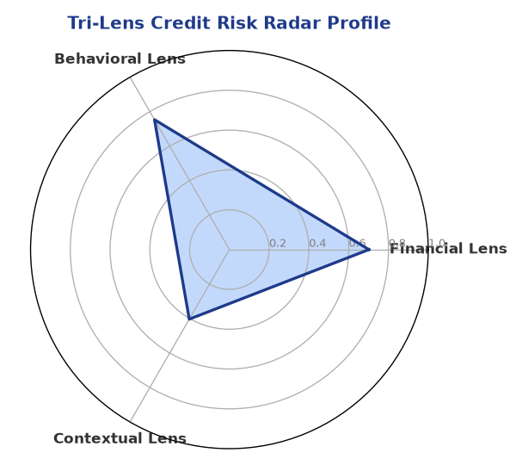
Multi-agent consensus radar chart (auto-embedded image)
SHAP Top-5 Risk Factors
# | Feature Name | SHAP Impact
1 | icr | 0.4500
2 | ebitda_margin | 0.4500
3 | gst_discrepancy_pct | 0.3487
4 | dscr | 0.3431
5 | current_ratio | 0.3415

Section C — AI Explainability: SHAP Waterfall
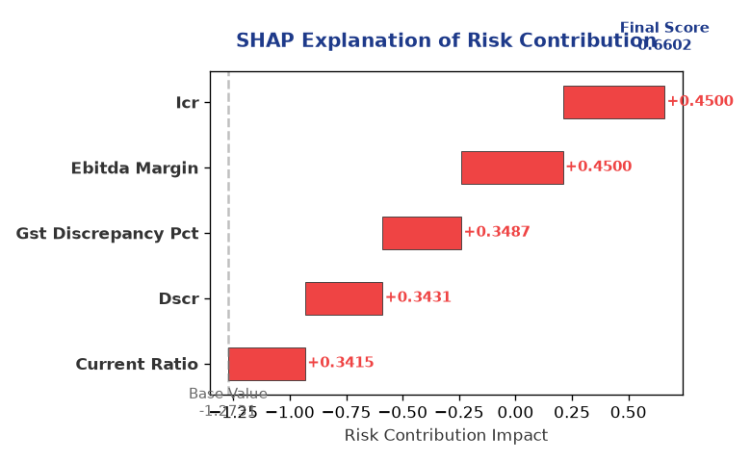
Explainability waterfall chart showing how the risk score was calculated

Section D — Rejection Reasons & Corrective Actions (LLM-Generated)
Rejection Reasons | Corrective Actions
• Stress Test Failed: Debt service capacity collapses under simulated stress.  • Forensic Alert: High Cheque Bounce Count (39 in 12 months).  • MCA Alert: Company flagged as defaulter on MCA21 registry. | • Improve DSCR by reducing debt or increasing cash flows  • Resolve ITC discrepancies between GSTR-2B and GSTR-3B

Section E — Comparable Case Analysis (Sector Peers & Database Search)
Assumption flagged: the data dictionary lists only sector-average tags (sector_avg_dscr / sector_avg_icr / sector_avg_leverage). The per-peer rows below assume a list variable named "peer_companies" (fields: name, turnover, dscr, icr, leverage, cibil, credit_status) using a docxtpl row-loop. Confirm/rename this against what the peer-comparison agent actually returns.

Company Name | Turnover | DSCR | ICR | Leverage | CIBIL | Credit Status
Sector Average | – | Data pending | Data pending | Data pending | – | –

7. Stress Testing & Resilience Analysis
The following scenarios were stress-tested against the applicant's financial position to evaluate resilience under adverse conditions.

Section A — Stress Scenarios (Agent 9: stress-agent)
# | Scenario | Shocked DSCR | Verdict
1 | Revenue-20% | -1.8551 | CRITICAL
2 | Rate+2% (Assumes 100% Floating Debt) | 0.0544 | CRITICAL
3 | Combined | -1.6867 | CRITICAL

Worst-Case DSCR | -1.8551
Overall Survival Verdict | CRITICAL

8. Ethical AI, Personal Discussion & Committee Sign-Off

Section A — Bias & Fairness Audit (Agent 10: bias-agent)
Counterfactual Tested | YES ✓
Decision Flips Detected | 0
Overweighted Features | 0
Bias Audit Summary (LLM-Generated)
Bias analysis pending.

Section B — Personal Discussion Summary (Agent 11: pd-agent)
Source Type | N/A
Risk Adjustment | +0.0000
PD Confidence Score | 0.00
Transcript Summary
No personal discussion was conducted; recommend scheduling one before final sign-off.
Qualitative Flags
None

Section C — Committee Sign-Off
Role | Name / Signature / Date
Prepared By | Trinetra Agentic Credit Intelligence OS
Reviewed By | _______________________________________
Approved By | _______________________________________
Date | _______________________________________
Signature | _______________________________________
DISCLAIMER: This Credit Appraisal Memorandum has been generated by the Trinetra Agentic Credit Intelligence OS. The AI-generated analysis is intended to assist credit officers and does not constitute a binding credit decision. All recommendations are subject to human review and approval in accordance with applicable regulations.

